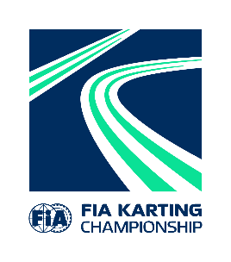
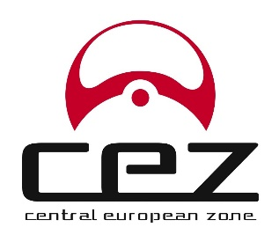
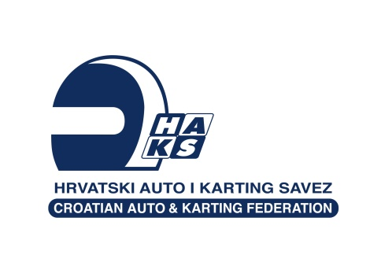

CEZ Zone Novi Marof
PRVENSTVO REPUBLIKE HRVATSKE/CROATIAN CHAMPIONSHIP
17. – 19. Svibanj / May 2024

Klasa/Class: __________BABY KART__________

Startni broj/Starting number: ________________

PRIJAVNI LIST/ENTRY FORM

Ime i prezime vozača
Name and surname of the driver: ________________________________________________
Datum rođenja/Date of birth: ________________________________________________
Adresa/Address: ________________________________________________
Broj mobitela/Mobile No: ________________________________________________
E-mail: ________________________________________________

Broj i rang vozačke licence
Drivers licence: number + rank: _________________________________________________

Natjecatelj/Competitor: _________________________________________________

Broje natjecateljske licence
Competitors licence No: _________________________________________________

VOZILO/VEHICLE:
Marka šasije/Make of chassis: _________________________________________________
Marka motora/ Make of engine: _________________________________________________

Potpis vozača Ovjera natjecatelja Datum i mjesto
Drivers signature: Competitors signature: Date and place:

____________________ ______________________ _________________

Poslati na/send to: momcilovic.matija@gmail.com
Do/till: 14.5.2024.
Plaćanje na/Pay to: Cash at the Event or to:
AKK Sportstil
Dunajska 337, 1000 Ljubljana
IBAN: SI56 2900 0005 5209 347 SWIFT: BACXSI22

