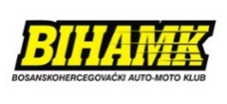
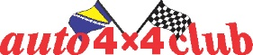
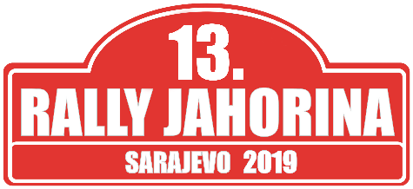
Starting No:
 | COMPETITOR - CLUB | DRIVER | CO-DRIVER
Name
Last name
First name
Pseudonym
Date of birth
Nationality
Address
Contact address
Landline phone no. (work)
Landline phone no.(home)
Mobile
Fax
E mail
Driver’s license no.
Competitior’s license no.
National Association
Issuing country

VEHICLE INFORMATION
Mark |  | Registration country
Model |  | Registration number
Year of production |  | Engine displacement (ccm)
Class |  | Chassis number
Homologation number |  | Driving license number

I’m applying for: | FIA CEZ |  | Cup BiH

Organiser’s proposed advertising accepted (choose): | YES | NO

ENTRY FEE
Deadline | Division 4 | Division 3 | Division 1, 2 + General Classification + CEZ
14.10.2019. unitil midnight | 100,00 KM (50 €) | 150,00 KM (75 €) | 200,00 KM (100 €)

PRIORITY INFORMATION

Driver: _____________________________________________ Vehicle: __________________________________

Class: _______________________________

FIA Priority A YES/NO Prior FIA priority YES/NO
FIA Priority B YES/NO If yes, year ________
National prirority YES/NO Priority ________
Winner of national championship YES/NO If yes, championship ________________ year ________

Year |  | Competition | Vehicle | Group | Final ranking | Class | Finishing competitors
International
National
Other

STATEMENT ON COMPENSATION
Competitor - club driver and co-driver, along with the accompanying crew accept and agree with the following:
- We are familiar with and we will abide and be bound by the rules of the Regulation for the 13. Rally Jahorina 2019, the competition which is being held according to the regulations of the International Sporting Code, Sporting and Technical Regulations of the FIA, the Regulations on motor sports SAMS BiH.
- We understand that motor sports are dangerous and that accidents can cause death, bodily harm, property damage and that by accepting this application, no one, neither FIA, nor SAMS BiH, nor the ORGANIZER nor any official person at the competition is liable for death, bodily harm or damage to the property caused by our participation at the
13thJahorina Rally 2019.
The driver is responsible for any possible failure to comply with the FIA and/or SAMS BiH Regulations, both on his/her behalf and on behalf of all other persons who were in any way connected with the driver’s performance in the competition.

STATEMENT AND ACCEPTANCE
With my signature I guarantee that all the data given in the application form is accurate and I fully recognize and accept the above stated conditions of compensation, and I accept the conditions relating to my participation in this competition.
Signature of the association * | Signature of the competitor – club | Signature of the driver | Signature of the co-driver

* Or the letter from the applicant’s national association allowing the application

Date ___________________________________

