Table of content

BASIC INFORMATION 3

CONTACT DETAILS 3

HEADQUARTER AND PRESS OFFICE 3

ENTRY DETAILS 5

SERVICE PARK 6

RECONNAISSANCE 6

SCRUTINEERING 6

QUALIFICATION 7

START PROCEDURE 7

FINISH PROCEDUE 7

OFFICIAL TEST 8

APPENDIX/ITINERARY AND MAPS 9

- BASIC INFORMATION

The Eger Rallye 2020 will be run in compliance with the International Sporting Code and its appendixes, the 2020 FIA Regional Rally Sporting Regulations and the National Rally Sporting Regulations which comply with the FIA regulations – National Championship Regulations 2020, National Sporting Regulations and the Supplementary Regulation.

Surface of SS 100,00% asphalt, Rallye1 (HIST, CEZ-HIST, RALLY1-ORC), Rallye2,

Rallye1, Rally1- ORC, HIST, CEZ-HIST Rallye2

Total length of rally: 583,20km (30,31%) 225,10km (38,45%)

Number of special stages: 16 7

Total length of special stages: 176,75 km 86,55 km

Number of sections: 7 4

Number of legs: 2 1

CONTACT DETAILS

E-mail | keletautosport@gmail.com
Website | www.eger-rali.hu
Facebook | To be published later
Instagram | To be published later
Clerc of the Course | Miklós Lovay
Organizer | Kelet-Autósport Kft.
CRO: | János Bernhardt, Krisztián Holecz

- HEADQUARTER AND PRESS OFFICE

Allure Hotel
3300. Eger, Liliom utca 1.
GPS: É 47°55,350’ K20°21,950’

Headquarter and Press Office opening hours:

- 2020.03.25. 09:00 – 18:00
- 2020.03.26. 08:00 – 18:00
- 2020.03.27. 07:00 – 20:00
- 2020.03.28. 07:00 – 22:00
- 2020.03.29. 07:00 – 20:00

2020.03.25. WEDNESDAY
09:00 – 18:00 | DISTRIBUTION OF ROAD BOOK (all competitors) | Eger, Allure Hotel
09:00 – 18:00 | RESONNAISSANCE (all competitors) | AS PER ROAD BOOK
2020.03.26. THURSDAY
08:00 - | DISTRIBUTION OF ROAD BOOK (except Rallye2) | HEADQUARTER
08:00 – 18:00 | DISTRIBUTION OF ROAD BOOK (RALLYE2) | HEADQUARTER
08:00 – 13:00 | ADMISNISTRATIVE CHECK (RALLYE1, RALLYE1-ORC, CEZ-HIST, HIST) | HEADQUARTER
13:30 – 19:00 | SCRUTINEERING (RALLYE1, RALLYE1-ORC, CEZ-HIST, HIST) | RENAULT "SHICK-R" Kft. Eger  Eger, Kistályai út 20, 3300
08:00 – 20:00 | RECONNAISSANCE | AS PER ROAD BOOK
13:00 – 16:00 | SERVICE PARK OPENING | AS PER ROAD BOOK
2020.03.27. FRIDAY
07:00 – 9:00 | DISTRIBUTION OF ROAD BOOK (RALLYE2) | HEADQUARTER
07:00 – 11:00 | ADMISNISTRATIVE CHECK | HEADQUARTER
07:30 – 11:30 | SCRUTINEERING | RENAULT "SHICK-R" Kft. Eger  Eger, Kistályai út 20, 3300
09:30 – 12:00 | QUALIFICATION | EGERSZALÓK-VERPELÉT
14:00- 14:30 | SELECTION OF STARTING POSITION | HEADQUARTER
14:30 | MANDATORY DRIVERS AND TEAM MANAGERS BRIEFING | HEADQUARTER
14:30 | PROVISIONAL START LIST PUBLICATION | HEADQUARTER, ONLINE NOTICE BOARD
15:00 | START LIST PUBLICATION | HEADQUARTER, ONLINE NOTICE BOARD
16:15 | START 1st LEG | AS PER ROAD BOOK
16:25 | START CEREMONY | AS PER ROAD BOOK
16:58 | START SUPERSPECIAL | AS PER ROAD BOOK
2020.03.28. SATURDAY
19:10 | FINISH 1st SECTION | AS PER ROAD BOOK
23:00 | 1.LEG PROVISIONAL RESULTS | HEADQUARTER, ONLINE NOTICE BOARD
2020.03.29. SUNDAY
07:00 | START 2nd SECTION | AS PER ROAD BOOK
17:07 | FINISH AND PRICE GIVING CEREMONY | AS PER ROAD BOOK
17:40 | FINISH OF THE EVENT | AS PER ROAD BOOK
18:00 | FINAL SCRUTINEERING | RENAULT "SHICK-R" Kft. Eger  Eger, Kistályai út 20, 3300
20:00 | PUBLICATION OF PROVISIONAL FINAL CLASSIFICATION | HEADQUARTER, ONLINE NOTICE BOARD
20.30 | PUBLICATION OF OFFICIAL FINAL CLASSIFICATION | HEADQUARTER, ONLINE NOTICE BOARD

- ENTRY DETAILS:

Titles for which the rally counts:

FIA CEZ HIST Rally 1. round (CEZ-HIST)

Hungarian National Rally Championship 2020 1. round (Rallye1)

Hungarian National Rallye Challenge 2020 1. round (Rallye1-ORC)

Hungarian Natianal Historic Rally Championship 2020 1. round (HIST)

Hungarian National Rally2 Championship 2020 1. round (R2)

Entry fees:
 | With advertising proposed by orginizer | Without advertising proposed by orginizer
RALLYE1 Championship:
4-wheel drive(4WD): | 218.440.- Ft. / 700€ | 431.800.- Ft. / 1400€
2-wheel drive (2WD): | 129.540.- Ft. / 330€ | 254.000.- Ft. / 660€
RALLYE1 ORC Championship:
P14 (4WD): | 167.640.- Ft. | 330.200.- Ft.
P11-13 and P14 up to 2510 cm³ (2WD): | 129.540.- Ft. | 254.000.- Ft.
RALLYE2 Championship:
RALLYE2: | 78.740.- Ft. | 152.400.- Ft.
RALLYE1 Historic Championship:
RALLYE1 Historic, CEZ-HIST: | 129.540.- Ft | 254.000.- Ft.
Előfutók:
RALLYE1 and Historic (max 4-4) | 150.000.- Ft | -
RALLYE2 (max 4): | 100.000.- Ft- | -

The entry fee has to be sent to organizer`s address:

Kelet-Autósport Kft.

3525 Miskolc, Kazinczy Ferenc utca 10. fszt/3.

Or has to be transferred to below account number:

Kelet-Autósport Kft.

Budapest Bank Zrt. 10102718-41877900-01004007

SWIFT-code: BUDAHUHB
IBAN: HU16-10102718-41877900-01004007

Championship | Rallye1 priority | Rallye1-ORC | Rallye1-Historic/CEZ | Rallye2
Supplementary regulation | 1 | 1 | 1 | 1
Road book | 2 | 1 | 1 | 1
Service road book | 2 | 1 | 2 | 1
Service plates | 2 | 1 | 2 | 1

SERVICE PARK

3300. Eger, Tárkányi u. 21
GPS: É 47°56,354’ K 20° 22,350’
Groundsheet under competition car during service is mandatory for all competitors. (min. 5x3m and impermeable to oil and fuel)! Every infringement will be sanctioned by the Stewards with penalty of 100.000 Ft,
Additional space and common service requests have to be sent to szervizpark.rallye@gmail.com latest by 16th of March 2020 12AM.

RECONNAISSANCE
AFTER ROAD BOOK DISTRIBUTION (no restriction)

SCRUTINEERING
RENAULT "SHICK-R" Kft. Eger
Eger, Kistályai út 20, 3300
GPS: É 47°52,078’ K20°24,300’
2020.03.26.  13:30 – 19:00 | SCRUTINEERING (RALLYE1, RALLYE1-ORC, CEZ-HIST, HIST) | RENAULT "SHICK-R" Kft. Eger  Eger, Kistályai út 20, 3300
2020.03.27.  07:30 – 11:30 | SCRUTINEERING | RENAULT "SHICK-R" Kft. Eger  Eger, Kistályai út 20, 3300

Following persons may appear in area of scrutineering besides the officials:
    - Two crew members, if they cannot be present the representative of the crew with licence or authorization
    - Team chef
    - Maximum 2 mechanics

Documents to be checked at scrutineering:

Enetered race car
    - Filled , readable scrutineering form passed the administrative check
    - Valid registration certificate or in case of Sport registration (SP reg.) with all official attachement
    - Homologation documents and used extensions
    - Certificates (Cage, tank, catalytic converter, ect.)
    - Valid car sporting passport issued by the ASN or FIA Technical Passportja or HTP in case of Historic cars.

Final scrutineering:
RENAULT "SHICK-R" Kft. Eger
Eger, Kistályai út 20, 3300
GPS: É 47°52,078’ K20°24,300’
2020.03.29. SUNDAY

- QUALIFICATION
Location: Egerszalók-Verpelét
Date: 2020.03.27. Friday 09:30 – 12:00

- START PROCEDURE
 | Rallye1 | Historic/CEZ | Rallye2
Ceremonial start  2020.03.27. Friday | IE/TC 0A  18:45 | IE/TC 0A  16:50 | IE/TC 0A  17:15
Start of 1st section | IE/TC 1B  06:00 | IE/TC 1B  07:40 | IE/TC 1B  08:15
Start of 2nd section | IE/TC 7F  07:00 | IE/TC 7F  08:30 | -

- FINISH PROCEDURE
 | Rallye1 | Historic/CEZ | Rallye2
Finish podium  2020.03.28. | - | - | IE/TC 7A  19:28
Finish podium  2020.03.29. | IE/TC 16A  17:07 | IE/TC 16A  18:37 | -

- OFFICIAL TEST
DATE: 2020.03.24. (Thursday) 08:00-19:00
LOCATION: Egerszalók-Verpelét
TEST ENTRY FEE: 300€ vagy 100.000, - Ft

Kelet-Autósport Kft.
Bank account: HUF 10102718-41877900-01004007
International bank acount- IBAN: HU16- 10102718-41877900-01004007
SWIF: BUDAHUHB

Service park:
3300. Eger, Tárkányi u. 21
GPS: É 47°56,354’ K 20° 22,350’

Test procedure:
With less than 30 participants test will be conducted back and forth direction.
Above 30 participants only 1 direction - Bükkszentlászló-Bükkszentkereszt
Starting procedure as per marshals instruction in 1 minute intervall.
Entry details:
Send email to keletautosport@gmail.com latest by 2020.03.10. (12AM). Entry list will be published on the 17th of March 2020.
Maps can be found in appendix.

Test package includes:
- Service area
- Toilets in the service area
- Insurance
- GPS units
- Rescue and medical units

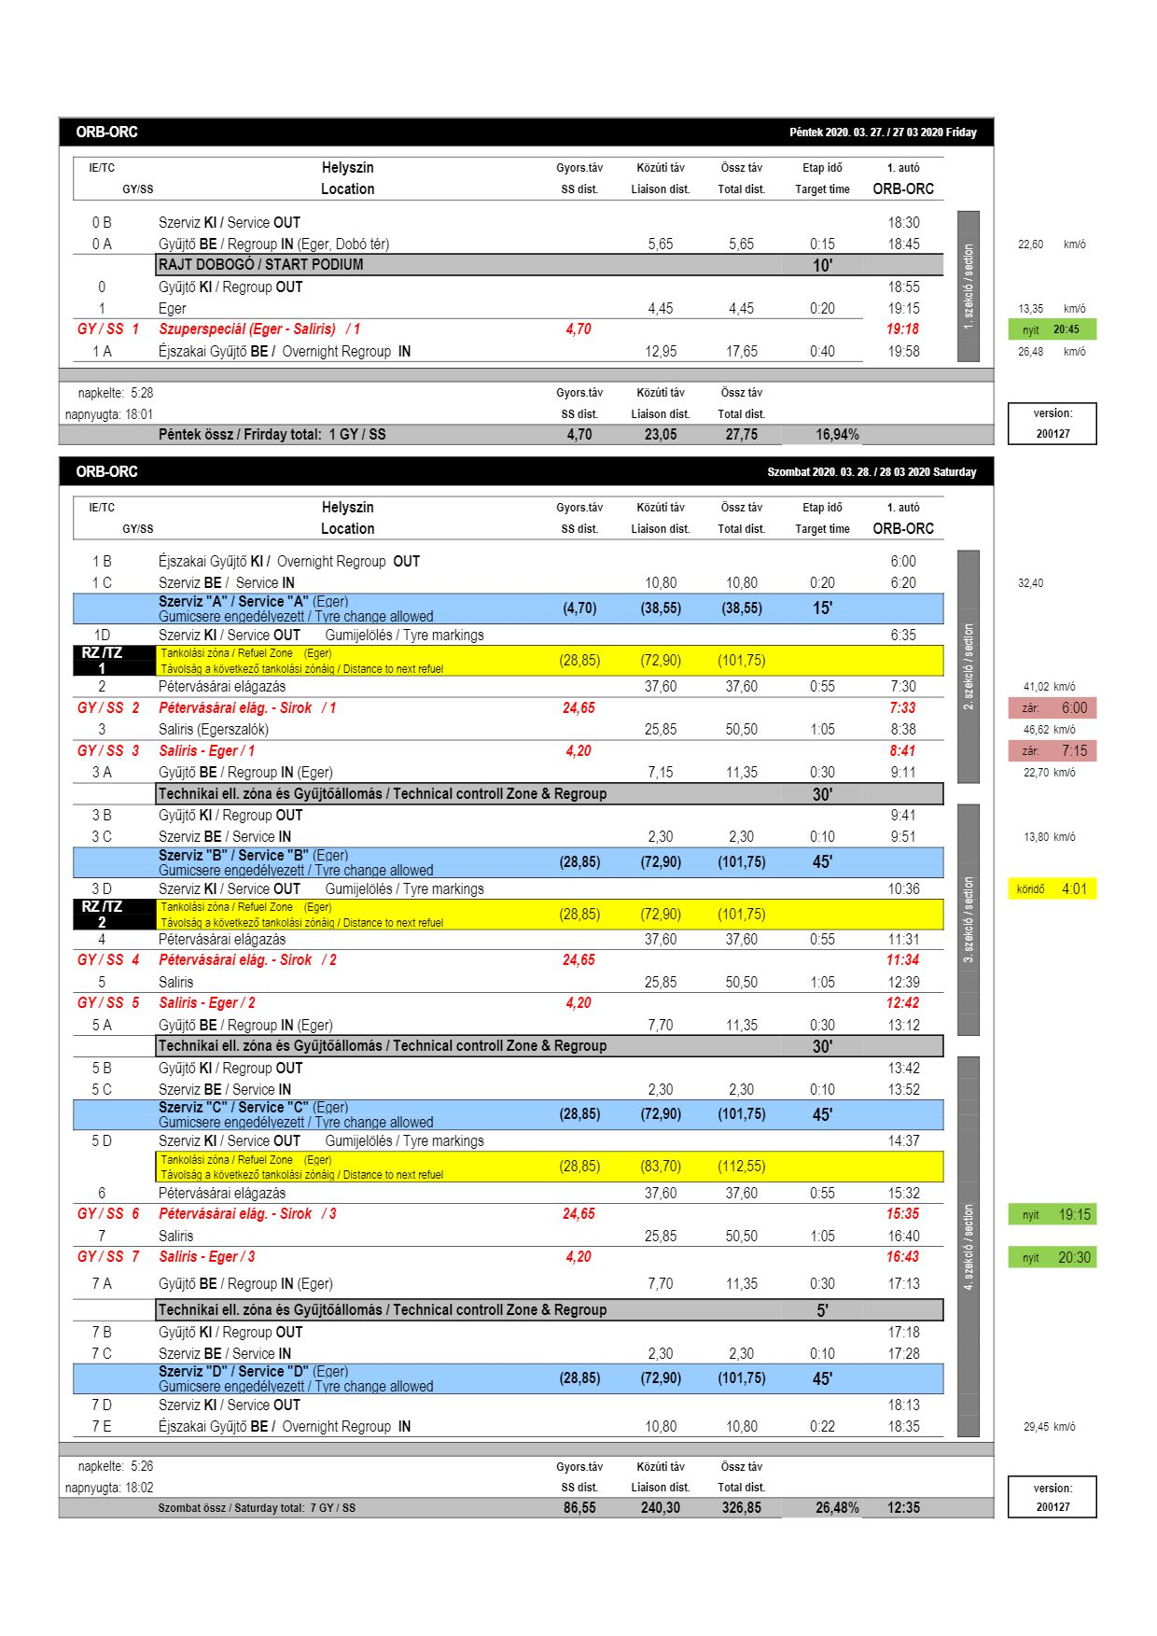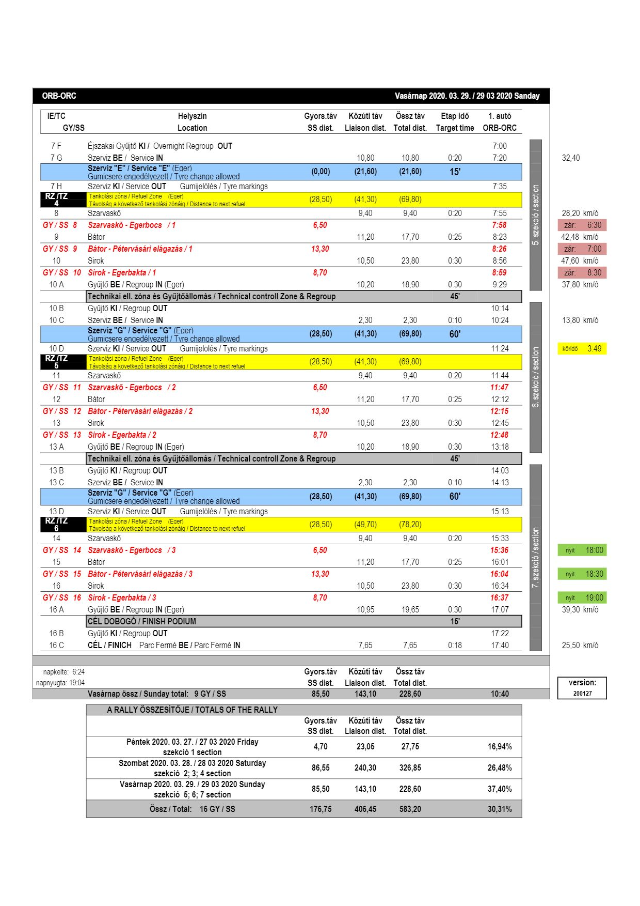

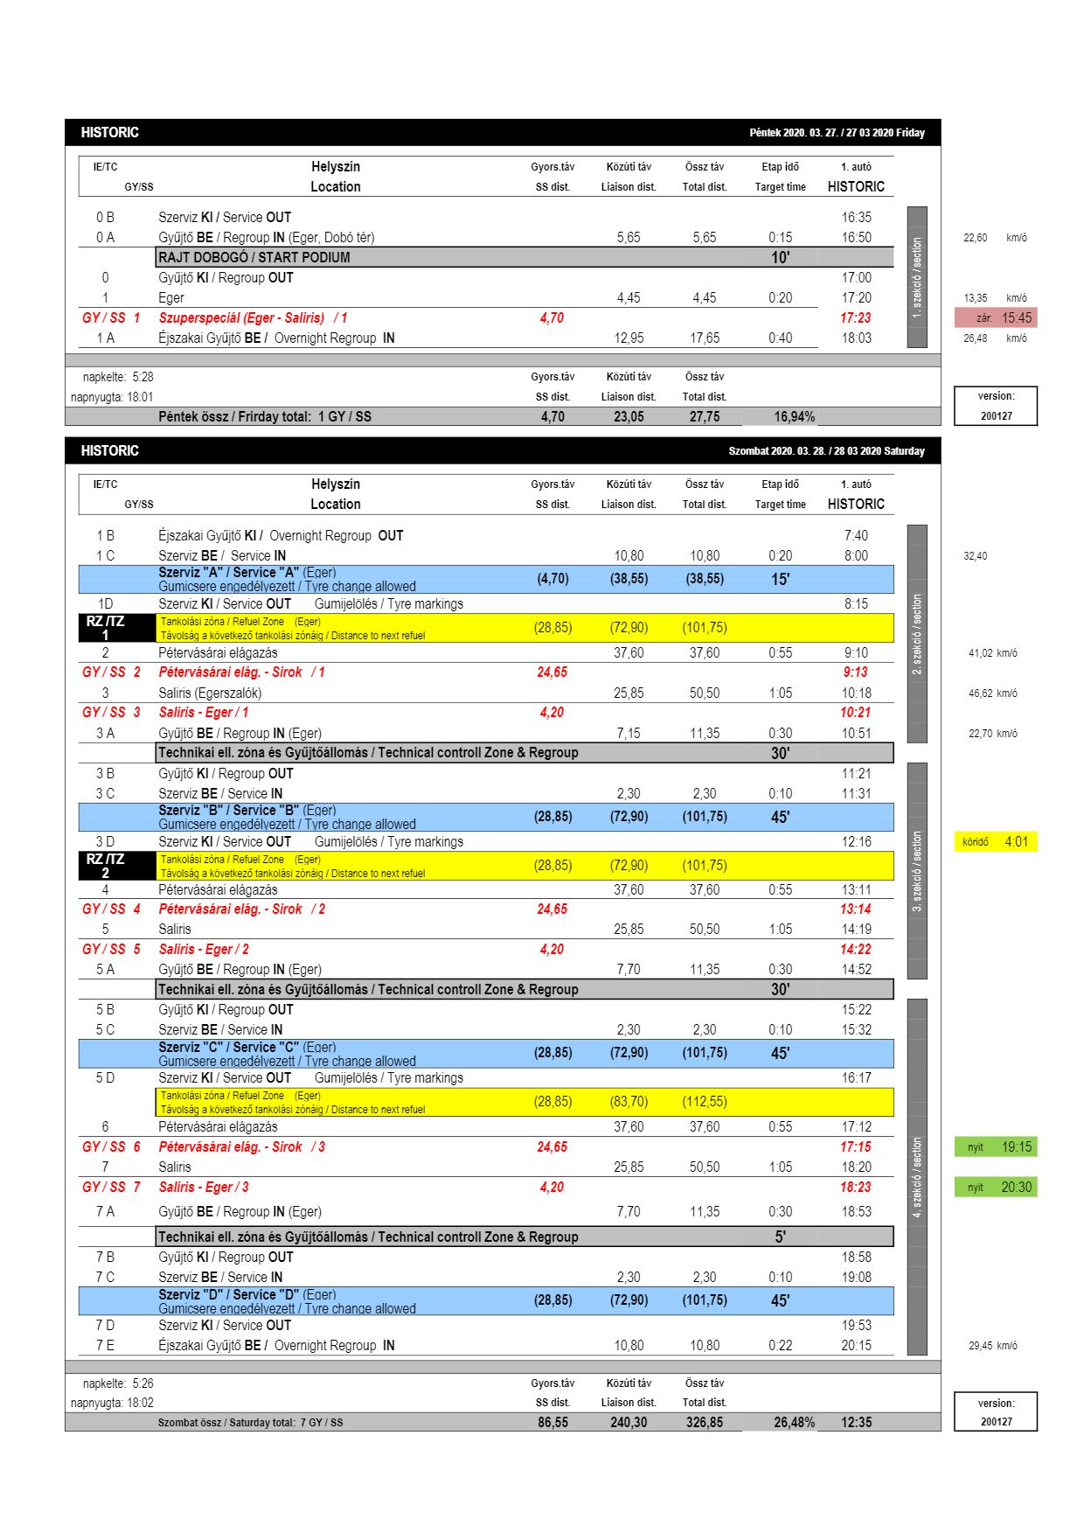

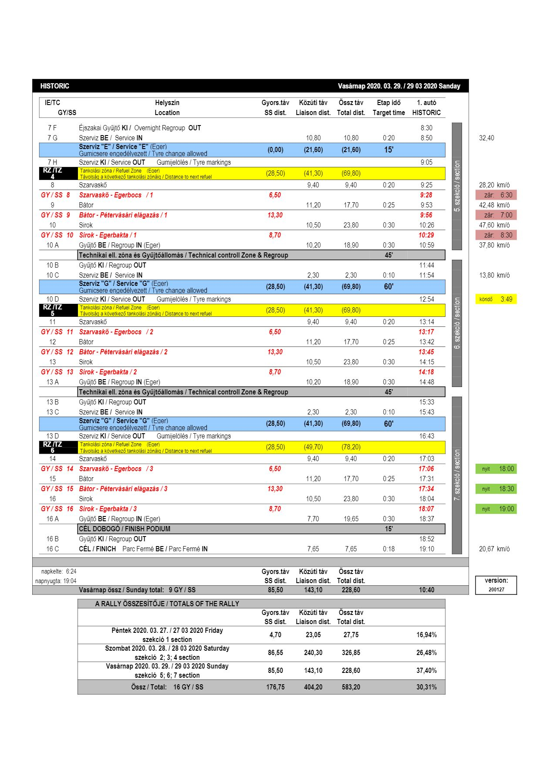

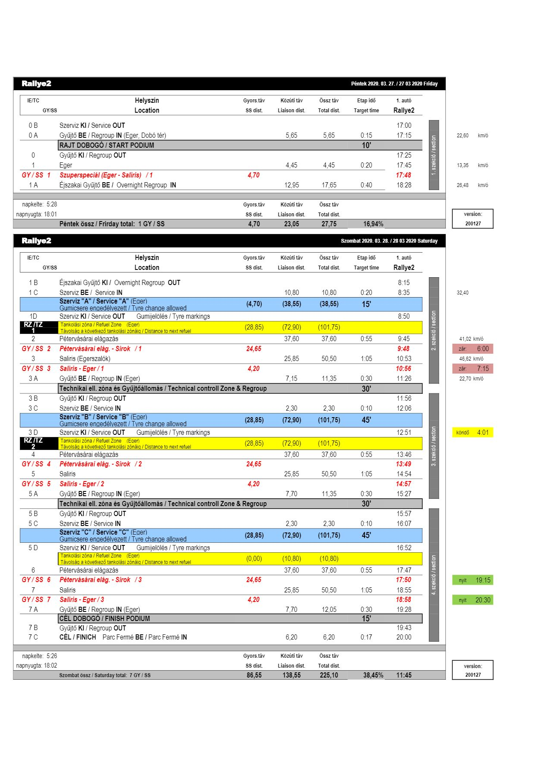

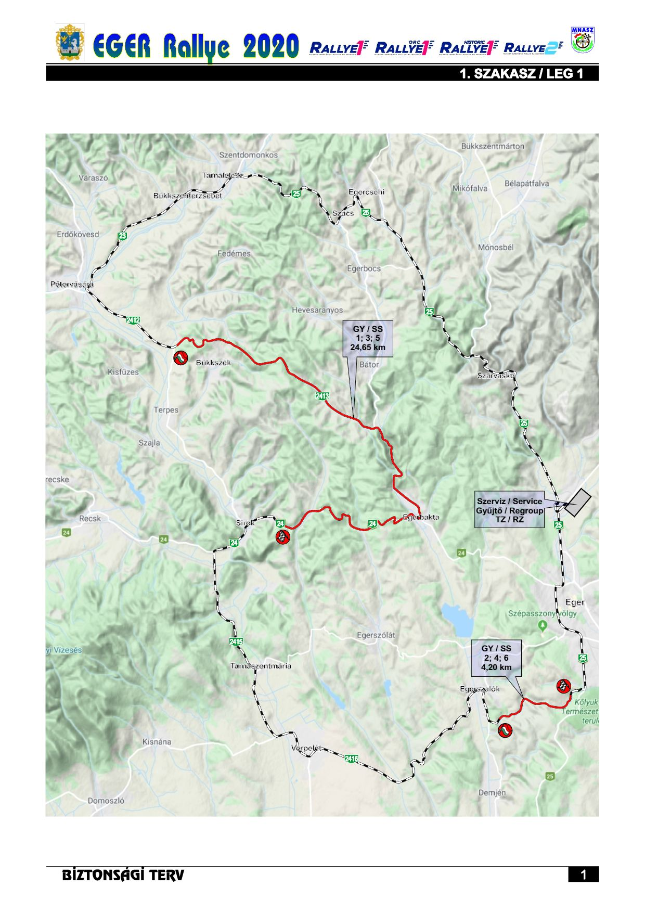

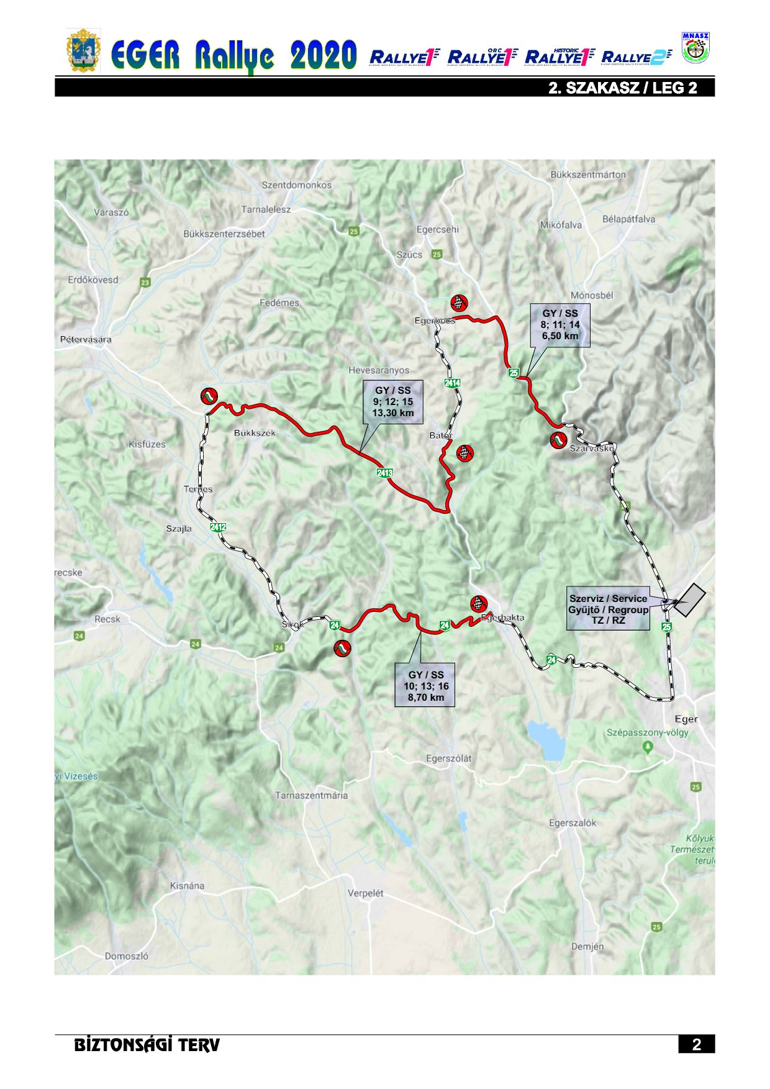

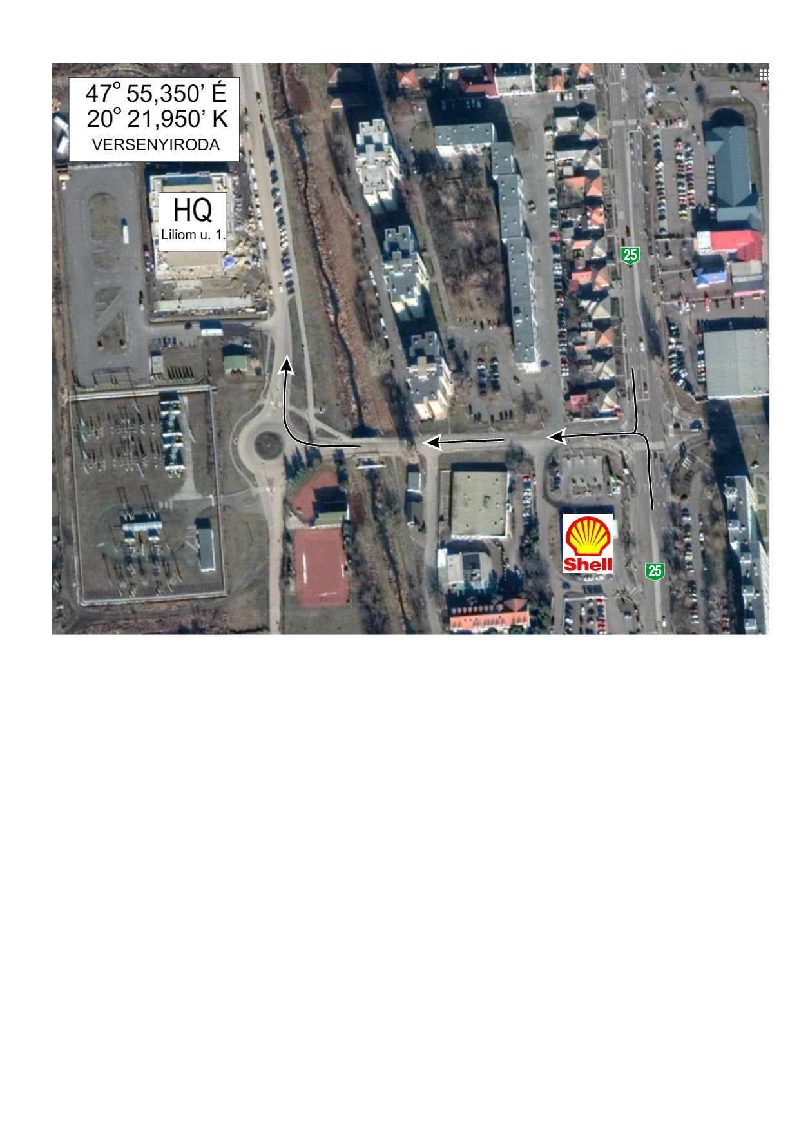

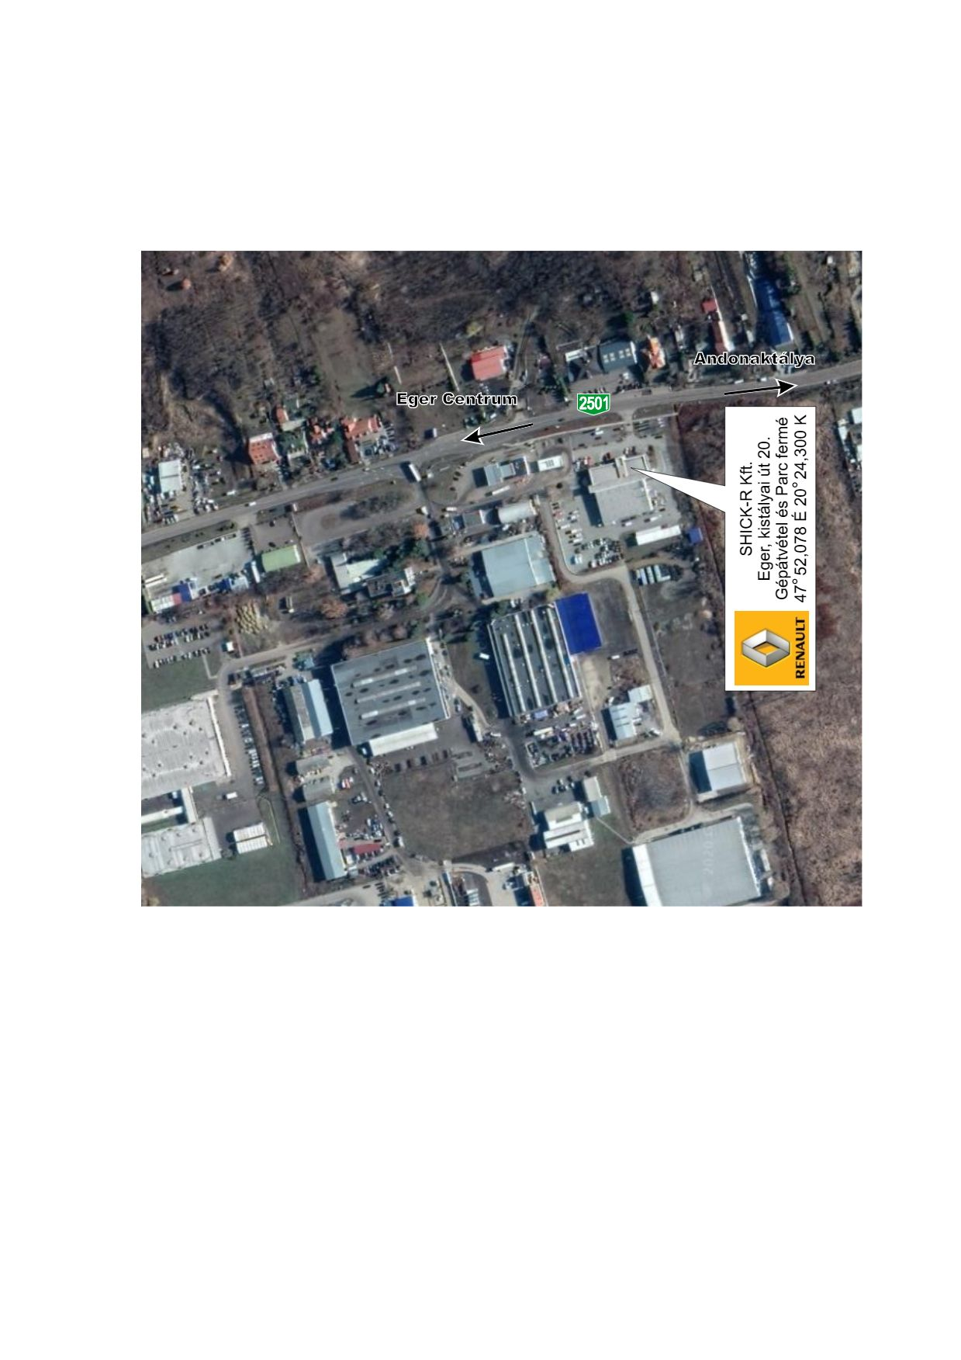

Service park